Tab 1

GANGA INSTITUTE OF TECHNOLOGY & MANAGEMENT
JHAJJAR, HARYANA

A PROJECT REPORT ON

“SMART TEMPERATURE MONITORING SYSTEM”

SUBMITTED OF THE REQUIREMENTS FOR THE TASK-1 ASSIGNMENT

MAINCRAFTS TECHNOLOGY INTERNSHIP :

INTRODUCTION TO EMBEDDED SYSTEM & IOT DEVICES DESIGN

SUBMITTED TO : SUBMITTED BY:
MAINCRAFTS TECHNOLOGY NAME -AMAN KUMAR
COLLEGE ROLL-24ECE005
PROGRAM - INTRODUCTION
TO EMBEDDED SYSTEM &
IOT DEVICE DESIGN

Tab 2
SMART TEMPERATURE MONITORING SYSTEM
ARDUINO UNO & DHT11 SENSOR

INTRODUCTION TO EMBEDDED SYSTEM

What is an Embedded System?

An embedded system is a computer-based system designed to perform a specific task. It consists of hardware (microcontroller, sensors, memory) and software (firmware) working together to control a device. Unlike a general-purpose computer, an embedded system is dedicated to one function and operates efficiently in real time.

Introduction

The Smart Temperature Monitoring System is an embedded system project that measures environmental temperature using a DHT11 sensor connected to an Arduino Uno. When the temperature exceeds a predefined threshold, the system activates an LED and a buzzer to alert the user.

Working Principal

The DHT11 sensor continuously measures the surrounding temperature.
The Arduino Uno reads the temperature every second.
This system provides simple real-time temperature monitoring and alert functionality.
If the temperature is greater than 35°C, the Arduino turns ON the LED and buzzer to alert the user.
If the temperature is below 35°C, both the LED and buzzer remain OFF.

Tab 3
Real-World Applications

- Hospital and Healthcare Temperature Monitoring : This system is used in hospitals and laboratories to monitor the temperature of medicine storage rooms, blood banks, and vaccine refrigerators.
- Cold Storage and Food Industry: The system is used in cold storage facilities to maintain the proper temperature for storing fruits, vegetables, dairy products, meat, and other perishable food items.
- Industrial Machine Monitoring: In industries, the system monitors the temperature of machines, motors, and electrical equipment.
- Smart Home Automation: The system can be integrated with smart home devices to automatically control fans, air conditioners, or ventilation systems based on the room temperature, improving comfort and saving energy.

Tab 4
Difference Between Microprocessor and Microcontroller

Microprocessors | Microcontroller

Used for general-purpose computing | Used for specific embedded tasks
Requires external RAM, ROM, and I/O devices. | CPU, RAM, ROM, and I/O are on a single chip.
Higher power consumption. | Lower power consumption.
More expensive. | More cost-effective.
Used in computers and laptops. | Used in Arduino, IoT devices, and home appliances.

Tab 5
Required components
- Arduino Uno
- TMP36Sensor
- LED
- 220Ω Resistor
- Buzzer
- Breadboard
- Jumper Wires

Circuit Diagram

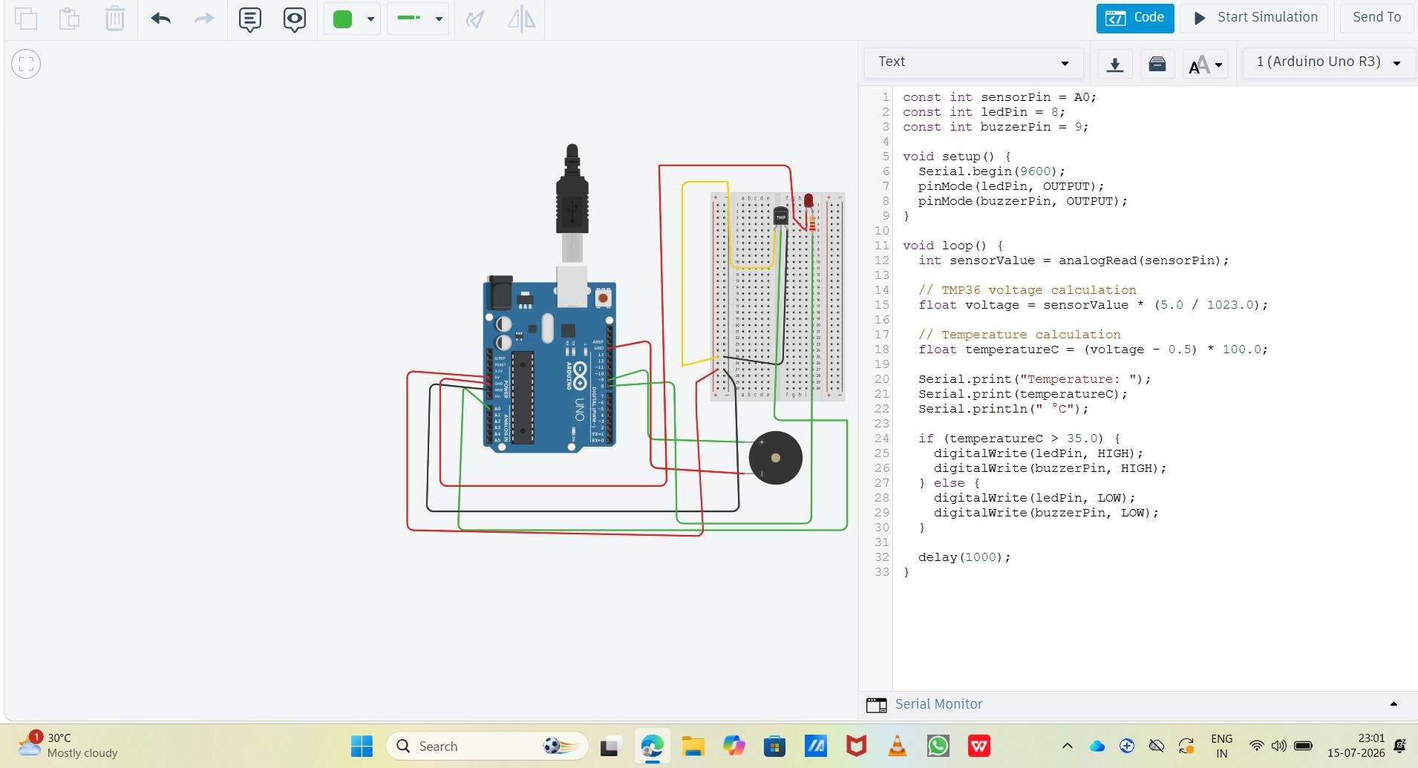

Tab 6
Programming

const int sensorPin = A0;
const int ledPin = 8;
const int buzzerPin = 9;

void setup() {
Serial.begin(9600);
pinMode(ledPin, OUTPUT);
pinMode(buzzerPin, OUTPUT);
}

void loop() {
int sensorValue = analogRead(sensorPin);

// TMP36 voltage calculation
float voltage = sensorValue * (5.0 / 1023.0);

// Temperature calculation
float temperatureC = (voltage - 0.5) * 100.0;

Serial.print("Temperature: ");
Serial.print(temperatureC);
Serial.println(" °C");

if (temperatureC > 35.0) {
digitalWrite(ledPin, HIGH);
digitalWrite(buzzerPin, HIGH);
} else {
digitalWrite(ledPin, LOW);
digitalWrite(buzzerPin, LOW);
}

delay(1000);
}

